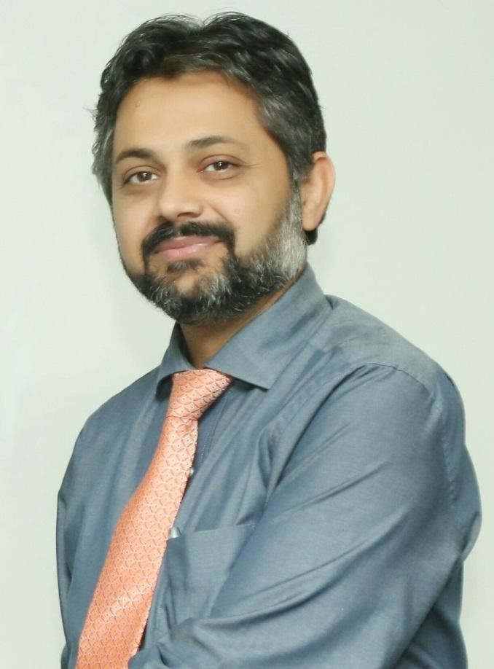
DR ZEESHAN ALI JUNEJO
MBBS, MCPS, FCPS (MED)
Member American College of Physicians (MACP)
Member American Gastroenterology Association
Vice President Pakistan Society of Hepatology (South)

CONSULTANT PHYSICIAN &
ASSOCIATE PROFEESOR OF MEDICINE
JINNAH POSTRADUATE MEDICAL CENTRE KARACHI
JINNAH SINDH MEDICAL UNIVERSITY KARACHI

Dr Zeeshan Ali has graduated from Liaquat Medical College Jamshoro Pakistan (Now Liaquat University of Health Sciences) in 1999.
He did his Fellowship & Membership in Internal Medicine in 2007 from College of Physicians & Surgeons Pakistan.
He is also Member of American College of Physicians & American Gastroenterology Association.
He is currently Vice President Pakistan Society of Hepatology South region.
He has been working at Jinnah Postgraduate Medical Center Karachi Pakistan, one the largest tertiary care hospital in Pakistan, from 2003 till date. During the course of training he had worked at Pakistan’s renowned tertiary care hospitals like Agha Khan University Hospital Karachi, Liaquat National Hospital Karachi and Pakistan Institute of
Medical Sciences Islamabad. He has been honorary faculty at Dow University of Health Sciences Karachi. He has various national & international peer reviewed articles. He is also supervising fellowship program for College of Physicians & Surgeons Pakistan.

