Name | KARIM KAMMERUDDIN
Designation | PROFESSOR OF MEDICINE
Email address | drkarimetal@yahoo.com
Introduction | Consultant Baqai University Hospital Nazimabad Karachi (B.U.H.N).
Specialization | Internal Medicine
Qualification | MBBS, FCPS ( General Medicine )
Professional Experience | - March. 2010 till date Working as Professor of Medicine and Incharge Hepatology Unit at Baqai University Hospital, Nazimabad, Karachi (B.U.H.N ).  - Aug. 2006 to March 2010: Worked as Associate Professor of Medicine and Incharge Hepatology Unit at Baqai University Hospital, Nazimabad, Karachi (B.U.H.N).  - April 2004 to July 2006: Worked as Associate Professor of Medicine & INCHARGE MEDICAL INTENSIVE CARE UNIT.  - Nov. 1999 to March 2004: Worked as Assistant Professor of Medicine and Incharge Medical Intensive Care Unit at Baqai University Hospital, Nazimabad, Karachi, (B.U.H.N.).
Awards | SEVEN DISTINCTIONS in five years of Medical Schooling i.e;  Distinctions in subject of Anatomy & Biochemistry, (First Professional M.B.B.S.).  Distinction in Pharmacology, (Second Professional M.B.B.S.).  Distinctions in Pathology & Community Medicine, (Third Professional M.B.B.S.).  Distinctions in Medicine & Ophthalmology, (Final Professional M.B.B.S.).  2nd position in Sindh Medical College, (First Professional M.B.B.S.).  3rd position in Karachi University, (Second Professional M.B.B.S.).  4th position in Karachi University, (Third Professional M.B.B.S.).  1st position in Karachi University, (Final Professional M.B.B.S.).  Received “Gold Medal” and “Certificate of Excellence” for “Best Graduate of the Year 1992” in 3rd Convocation of Sindh Medical College.  Cleared (both parts) of FCPS in 1st attempt.
Research  interests | Diabetes, H.T.N & (Viral)Hepatology
National / International Publications/Posters | Twelve

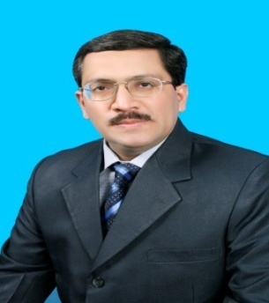
CURRICULUM VITAE

